**SQL for Data Science**

1. Powerful language for communicating with databases
   1. Any application needs to store that data somewhere
   2. Big data, table with a few rows, small start ups, big database, mobile phone
2. Advantages
   1. Boost professional profile
   2. Give you a good understanding of relational databases
   3. SQL STATEMENTS!!!
3. Connect to database and run SQL queries
4. Python and Jupyter Notebooks to analyze Data

**Introduction to Databases**

1. SQL: A language used for relational databases to query data or get data out of a database
2. Strucred English Query Language
3. Data: Collection of facts in the form of words, numbers or pictures
   1. One of the most critical aspects of any business
   2. Needs to be sucure
4. Database: Respository of data
   1. Provides the functionality for adding, modifying and querying that data
   2. Different kinds of databases store data in different forms
      1. Relational: tabular form (columns and rows)
5. DBMS: DATABASE MANAGEMENT SYSTEM – Software to manage databases
   1. A.K.A. database, batabase server, database system, data server
6. RDBMS: Relational database management system
   1. Set of software tools that controls the data
      1. Access, organization and storage
   2. Examples: MySQL, Oracle Database, IBM Db2, etc
7. Basic SQL Commands
   1. Create a table
   2. Insert
   3. Select
   4. Update
   5. Delete

**Select Statement**

* + - 1. Retrieving Rows from a Table
      2. Use a SELECt statement
         1. A data manipulation language (DML) statement used to read and modify data
         2. Select statement: query
         3. Result from the query: result set/table

Select * from <tablename>

E.G. Select * from Book

E.G. select<column 1, column 2, column n from Book

Db2: select book_id, title, edition, year, price, ISBN, pages, description

* + - 1. Restricting the result set: WHERE clause
         1. Restricts the result set
         2. Always requires a predicate

Evaluates to true, false or unknown

Used in the search condition of the where clause

* + - * 1. Select book_id, title from Book WHERE book_id= ‘B1’
        2. Comparison Operators:

Equal to =

Great than >

Less than <

Greater than or equal to >=

Less than or equal to <=

Not equal to <>

**Select Statement Examples**

The general syntax of SELECT statements is:

**select COLUMN1, COLUMN2, ... from TABLE1 ;**

To retrieve all columns from the COUNTRY table we could use "*" instead of specifying individual column names:

**select * from COUNTRY ;**

The WHERE clause can be added to your query to filter results or get specific rows of data. To retrieve data for all rows in the COUNTRY table where the ID is less than 5:

**select * from COUNTRY where ID < 5 ;**

In case of character based columns the values of the predicates in the where clause need to be enclosed in single quotes. To retrieve the data for the country with country code "CA" we would issue:

**select * from COUNTRY where CCODE = 'CA'; **

**Count Distinct Limit**

1. COUNT(): A built-in function that retrieves the number of rows matching the query criteria
   1. Select COUNT (*) from tablename
   2. E.g. Rows in the MEDALS table where country is Canada:
      1. Select COUNT (COUNTRY) from MEDALS where COUNTRY = ‘Canada’
2. DISTINCT: Used to remove duplicate values from a result set.
   1. Select DISTINCT colum name from tablename
   2. E.g. select DISTINCT COUNTRY from MEDALS where MEDALTYPE = gold
3. LIMIT: Restricting the number of rows retrieved from the database
   1. E.g. retrieve just the first 10 rows: select * from tablename LIMIT 10
   2. E.g. select * from MEDALS where YEAR = 2018 LIMIT 5
4. OFFSET: From which row to start

**Limit Statement**

* + - 1. Adding rows to a table
         1. Create the table (CREATE TABLE statement)
         2. Populate table with data

INSERT statement

* + - 1. INSERT: INSERT INTO [TableName] <([ColumnName],…)> VALUES ([value, …)
         1. INTERT INTO AUTHOR (AUTHOR_ID, LASTNAME, FIRSTNAME< EMAIL< CITY< COUNTRY)
         2. VALUES (‘A1’, ‘Chong’, ‘Raul’, ‘rfc@ibm.com’, ‘Toronto’, ‘CA’)

**Update and Delete Statements**

After creating a table and inserting data into the table, we can alter the data

UPDATE statement: A Data Manipulation Language (DML) statement used to read and modify data

UPDATE: [TableName] SET [[ColomnName]=Value]]<WHERE [Condition]>

UPDATE AUTHOR SET LASTNAME=’KATTA’ FIRSTNAME=’LAKSHMI’ WHERE AUTHOR_ID=’A2’

DELETE: DELTE FROM [TableName] < WHERE [Condition]>

DELETE FROM AUTHOR WHERE AUTHOR_ID in (‘A2’, ‘A3’)

**Introduction to Relational Databases and Tables**

**Relational Database Concepts**

1. Relational Model
   1. Most used model for databases
   2. Allows for data independence
   3. Data is stored in tables
      1. Logical data independence – physical data independence – physical storage independence.
2. Entity Relational Data Model (ER)
   1. Alternative of relational model
   2. Collection of entities
   3. Used as a tool to design relational databases
   4. Entities are objects that exist independtenly of any other entities in the databse
   5. Entity: Noun (e.g. book)
      1. Drawn as rectangles
   6. Attributes: (elements that characterize the entity) (E.g. author, pages, year, ISBN)
      1. Drawn as ovals
   7. The entity (book) becomes a table in the database
   8. The attributes become the columns in the table
   9. Data is added to form the rows

**How to create a Database instance on cloud**

* + - 1. Cloud databases: Database service built and accessed through a cloud platform
      2. Benefits
         1. Ease of use and Access

API

Web Interface

Cloud or Remote Applications

* + - * 1. Scalability & Economics

Expand/Shrink Storage & Compute Resources

Pay per use

* + - * 1. Disaster Recovery

Cloud backups and geographical distribution

* + - 1. Examples of Cloud Databases
         1. IBM Db2
         2. Databases for PostgreSQL
         3. Oracle Database Cloud Service
         4. Microsoft Azure SQL Database
         5. Amazon Relational Database Services (RDS)

Available as Virtual Machine or Managed Service

Single or multi-tenant

* + - 1. Database Service Instance
         1. DBaaS provides users with access to Database resources in cloud without setting up hardware and installing software and administering the database
         2. Database service instance wild old data in data objects/tables
         3. Once data is loaded, it can be queried using web interfaces and applications
         4. Connect to data base using API’s
         5. Send SQL queries across to the database instance
         6. Data sent from database instance as a result set
      2. Creating a database instance on IBM db2 on Cloud
         1. Ibm cloud catalogue and select Db2 service

**Types of SQL Statements**

DDL (Data Definition Language) Statements:

Define, change, or drop data

CREATE: Creating tables and defining its columns

ALTER: Altering tables, dropping columns and modifying data types

TRUNATE: deleting data in a table but not the table itself

DROP: Used for deleting tables

DML (Data Manipulation Language statements

Read and modify data

CRUD Operations (Create, Read, Update and Delete rows)

CREATE  
INSERT: Inserting row(s) of data into a table

SELECT: Reads or selects row(rows)

UPDATE: Edit row(s) in a table

DELETE: Removes row(s) of data from a table

**Create a Table Statement**

1. Syntax: CREATE TABLE table_name
   1. (
   2. Column_name_1 datatype optional_parameters,
   3. Column_name_2 datatype,
   4. Column_name_n datatype
2. Create a table for Canadian provinces
   1. CREATE TABLE provinces (
   2. Id char (2) PRIMARY KEY NOT NULL,
   3. Name varchar (24)
   4. )
3. Char: Character string of a fixed length (2)
4. Varchar: Character string of a variable length (field up to 24 characters long)

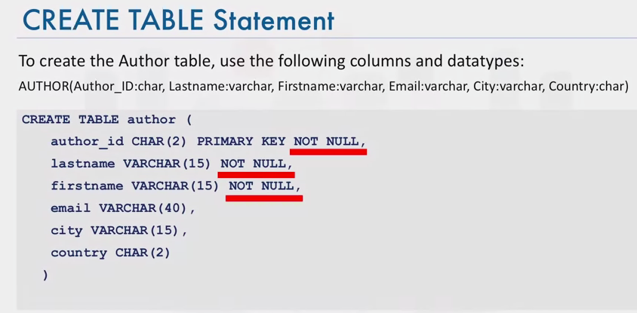

1. Author_id is the primary key – prevents duplicates in the table
2. Null: these fields cannot contain a null value

**Alter, drop and Truncate Tables**

1. ALTER TABLE
   1. Add or remove columns
   2. Modify the data type of column
   3. Add or remove keys
   4. Add or remove constraints

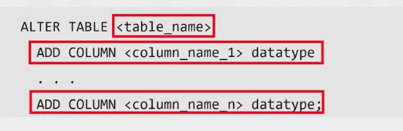

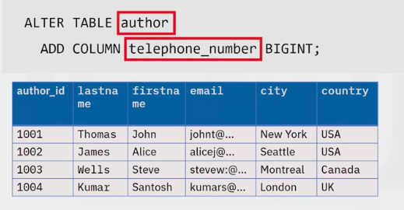

* 1. BIGINT: Can hold a number up to 19 digits long

1. DROP TABLE:

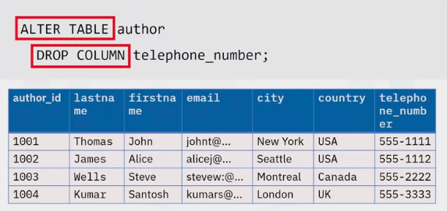

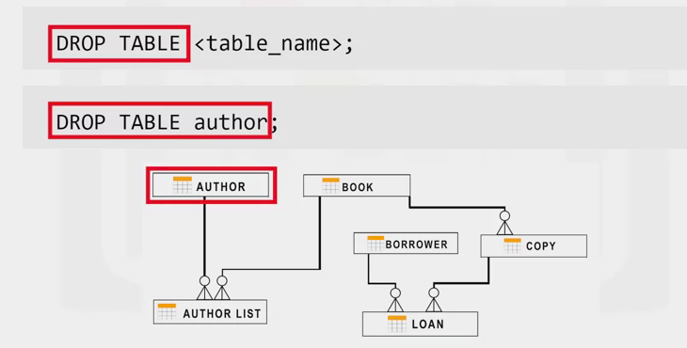

1. TRUNCATE TABLE:

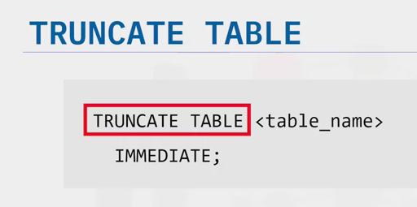

**USING STRING PATTERNS AND RANGES – week 3**

1. Main purpose of a database management system is not just to store the data but also facilitate retrieval of the data

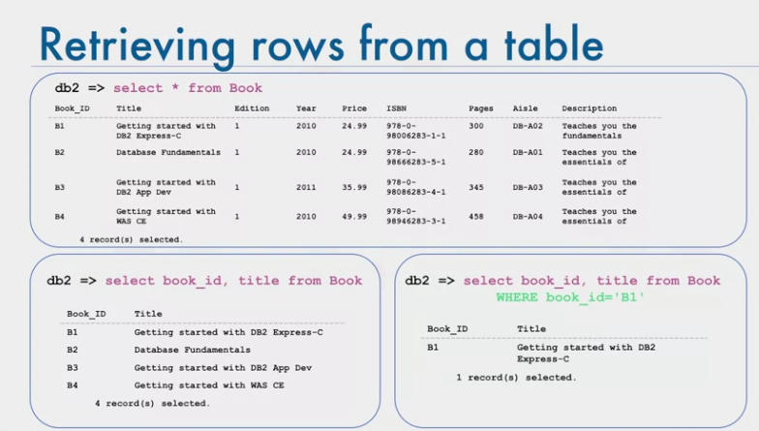

1. Db2 => select * from Book
2. WHERE clause: Restricts the result set
3. WHERE clause requires a predicate
   1. An expression that evaluates to true, false or unknown
4. If you cant remember id no. then you can use the **WHERE clause with a LIKE** predicate
   1. Where <columnname> Like <String pattern>
   2. WHERE firstname LIKE R%
      1. % sign is used to define missing letters
   3. Db2 => select firstname from Author WHERE firstname like R%

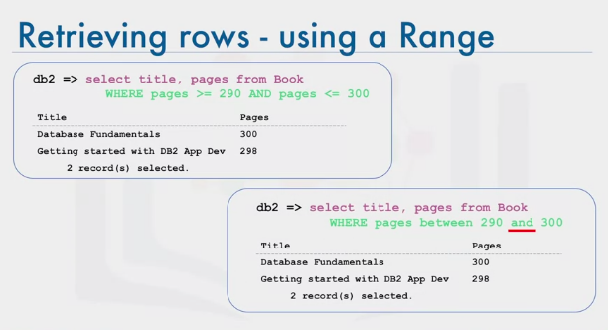

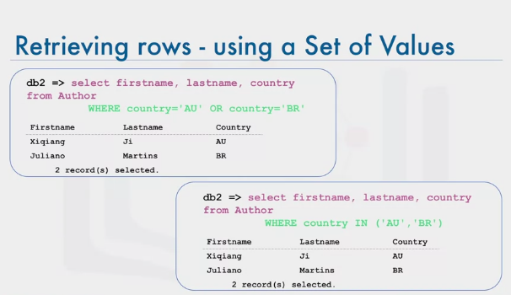

1. IN operator allows us to specify a set of values in a WHERE clause

**SORTING RESULT SETS**

1. ORDER BY clause

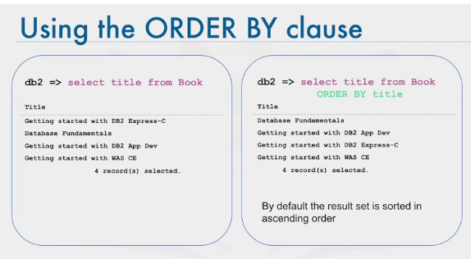

1. Order by descending order DESC

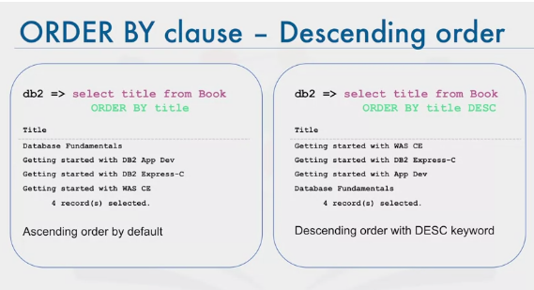

1. Indicate the column sequence number: Sort order by pages

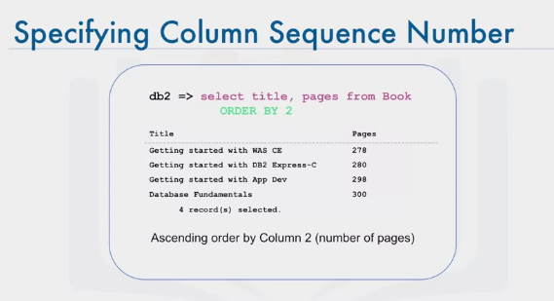

**GROUPING RESULT SETS**

1. Eliminating Duplicates – DISCTINCT clause
   1. Db2 => select distinct (country) from Author
2. GROUP BY clause
   1. Db2 => select country, count (country) from Author GROUP BY country
   2. Groups a results into subsets that have matching values for one or more columns
3. Assign a column name to the result set – AS COUNT
   1. Db2 => select country, count (country) AS COUNT from author group by country
4. HAVING: Sets the condition to a group by clause
   1. Db2 => select country, count(country) as Count from Author group by country HAVING count (country) >4

**FUNCTIONS, MULTIPLE TABLES, AND SUBQUERIES**

**Built in Database Functions**

1. Most databases come with built in functions
2. Built in functions can be included as part of SQL statements
3. Data functions can significantly reduce the amount of data that needs to be retrieved
4. Can speed up data processing
   1. Can create user defined functions
   2. Large datasets: use built in functions rather than first retrieving the data into your applications
5. AGGREGATE OR COLUMN FUNCTIONS
6. Aggregate
   1. Takes a collection of like values as INPUT (e.g. entire column) and return a single OUTPUT (single value, or null)
   2. SUM(), MIN(), MAX(), AVG(), ETC
7. Add Values: SUM (COLUMN_NAME)
   1. SELECT SUM(COST) FROM PETRESCUE
8. Naming the output
   1. SELECT SUM(COST) AS SUM_OF_COST FROM PETRESCUE
9. MAXIMUM
   1. SELECT MAX (QUANTITY) FROM PETRESCUE
10. Subset of data instead of entre column
    1. Get the minimum value of ID column for Dogs:
    2. SELECT MIN(ID) FROM PETRESCUE WHERE ANIMAL = ‘DOG’
11. AVG()
    1. SELECT AVG (COST) FROM PETRESCUE
12. MATHEMATICAL OPERATIONS
    1. SELECCT AVG(COST/QUANTITY) FROM PETRESCUE WHERE ANIMAL = ‘DOG’

**SCALAR AND STRING FUNCTIONS**

1. ROUND(), LENGTH(), UCASE, LCASE
2. ROUND: SELECT ROUND(COST) FROM PETRESCUE
3. STRINGE FUNCTIONS: SELECT LENGTH (ANIMAL) FROM PETRESCUE
4. UCASE: SELECT UCASE (ANIMAL) FROM PETRESCUE
5. Can be used with a WHERE clause
   1. SELECT * FROM PETRESCUE WHERE LCASE(ANIMAL) = ‘CAT’
6. Can be used with DISTINCT CLAUSE
   1. SELECT DISTINCT(UCASE(ANIMAL)) FROM PETRESCUE

**DATE AND TIME BUILT-IN FUNCTIONS**

* + - 1. DATE: YYYYMMDD
      2. TIME: HHMMSS
      3. TIMESTAMP: YYYYXXDDHHMMSSZZZZZ
      4. Date/time Functions
         1. YEAR(), MONTH(), DAY(), DAYOFMONTH(), DAYOFWEEK(), DAYOFYEAR(), WEEK(), HOUR(), MINUTE(), SECOND()
      5. Extract day portion from a date:
         1. SELECT DAY(RESCUEDATE) FROM PETRESCUE WHERE ANIMAL = ‘CAT’
      6. WHERE clause to get the number of rescues during the month of May:
         1. SELECT COUNT(*) FROM PETRESCUE WHERE MONTH(RESCUEDATE) = ‘05’
      7. Date or Time Arithmetic
         1. SELECT (RESCUEDATE + 3 DAYS) FROM PETRESCUE
      8. CURRECT_DATE, CURRENT_TIME
         1. Find how many days have passed since each Rescuedate till now:
         2. SELECT (CURRENTDATE – RESCUEDATE) FROM PETRESCUE

**SUB-QUERIES AND NESTED SELECTS**

1. Subquery placed in parenthesis and inside another query

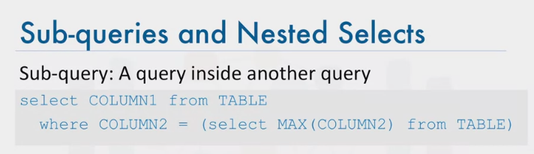

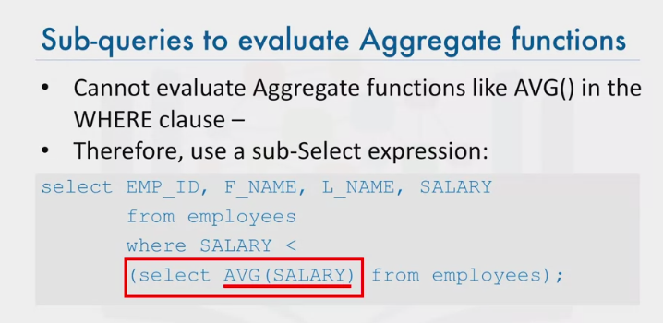

1. Doesn’t only need to be in the WHERE clause. Can also be in columns to be selected
   1. Thus called column expressions

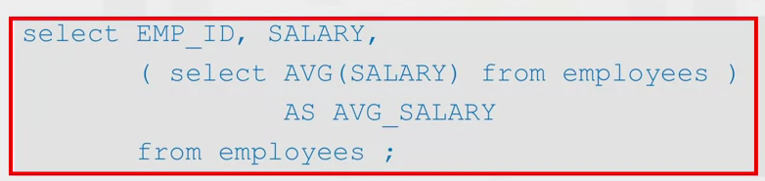

1. Subqueries in FROM clause
   1. Substitute the TABLE name with a sub-query
   2. Called Derived Tables or Table Expressions
   3. Outer query uses the subquery as a data source

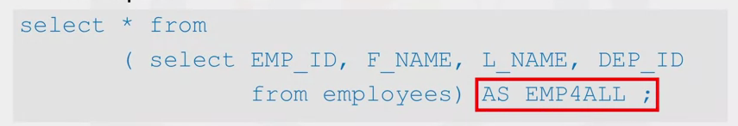

**Working with Multiple Tables**

1. Ways to access multiple tables in the same query
   1. Sub-queries
   2. Implicit JOIN
   3. JOIN operators (INNER JOIN, OUTER JOIN, etc)
2. SUB-queries to Access multiple tables

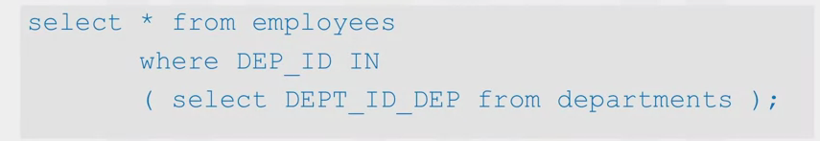

* 1. Outer query accesses the employees table
  2. The sub query is used to filter the outer query

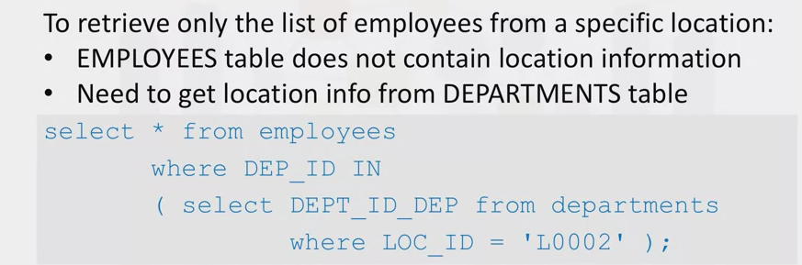

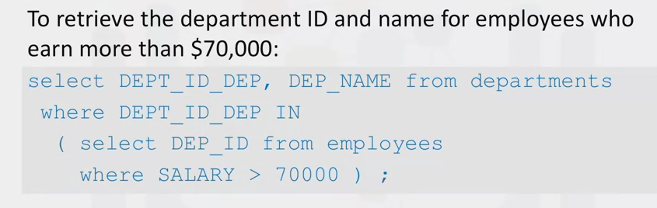

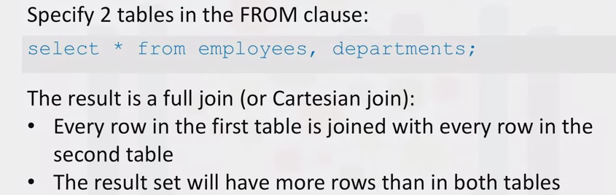

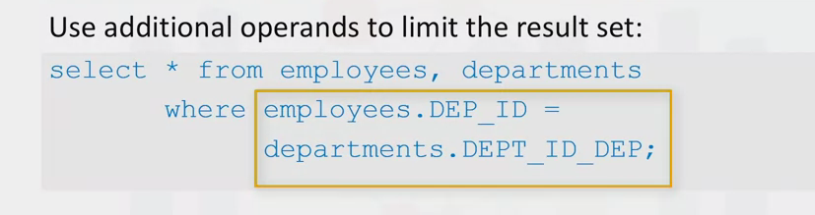

1. In the WHERE clause you prefix the name of the column with the name of the table. This is to fully qualify the column name since it is possible that different tables have some columns that are exactly the same

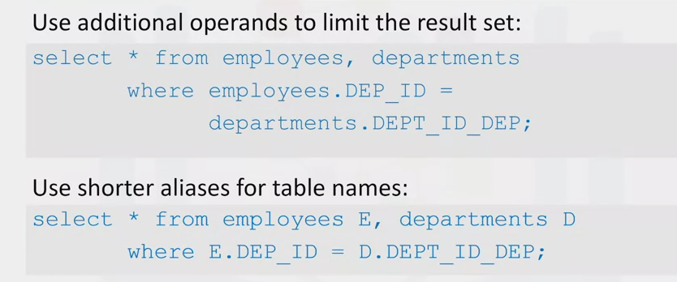

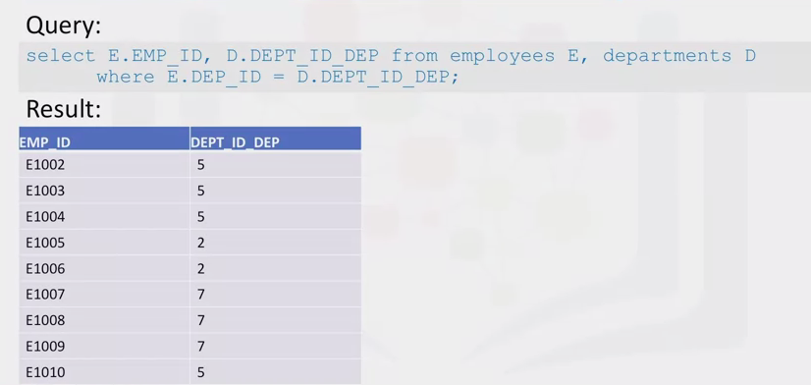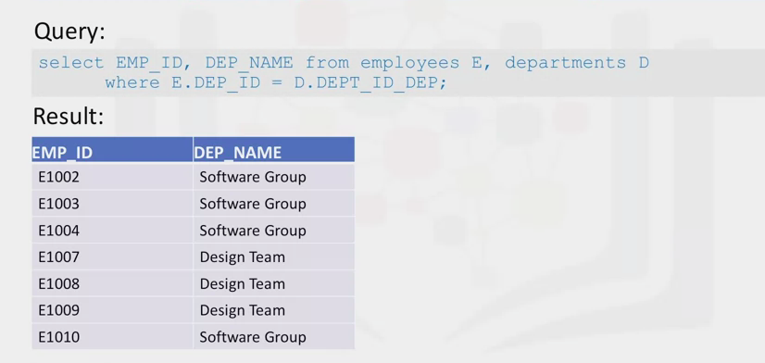

**ACCESSING DATABASES USING PYTHON**

1. Benefits of using Python
   1. Python ecosystem: NumPy, pandas, matplotlib, SciPy
   2. Ease of use
   3. Portable
   4. Python supports relational database systems
   5. Python database API (DB-API)
   6. Detailed documentation
2. Introduction to Notebooks
   1. They run in an environment and sharing of documents that contain live code, aquations, visualizations, explanatory text
   2. Notebook interface: Virtual notebook environment usd for programming
      1. Mathamatica, maple worksheet, Matlab, iPython, Jupyter, R Markdown, Apache Zeppelin, Apache Spark and the Databricks cloud
3. What are Jupyter Notebooks?
   1. Language of choice (over 40 languages)
   2. Shared notebooks
   3. Interactive output
   4. Big data integration
   5. Explore with pandas, scikitlearn, ggplot2 and tensorflow
4. What is a SQL API?
   1. API: Set of functions you can call to get some type of service
   2. The SQL API consists of library function calls as an API for the DBMS
   3. To pass SQL statements to the DBMS, an application program calls functions in the API, and it calls other functions to retrieve query results and status information from the DBMS.
   4. To send SQL statement to the DBMS, the proram builds the statements as a text string in a buffer and then make an API call to pass the buffer contents to the DBMS
   5. Application program makes API calls to check the status of its DBMS request and to handle errors

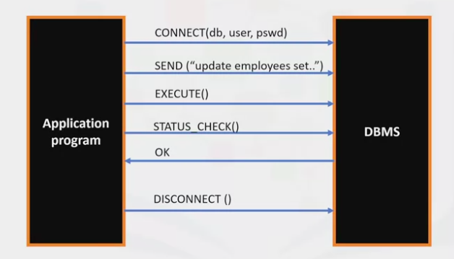

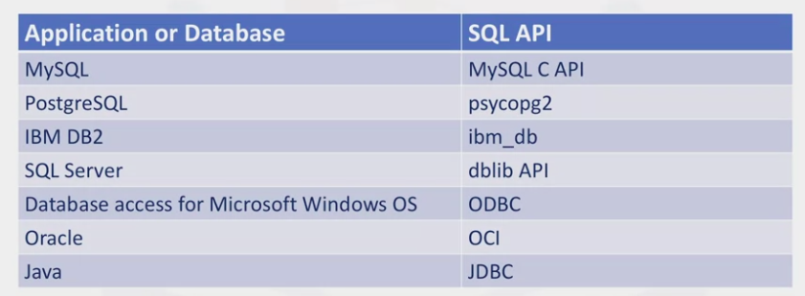

**Writing Code using DB-API**

1. DB API calls are Python’s standard API for accessing relational databases
2. Allows a single program to work with multiple relational databases

**Benefits of using DB-API**

1. Easy to implement and understand
2. Encourages similarity between the Python modules used to access databases
3. Achieves consistency: easily understood modules
4. Portable across databases
5. Broad reach of batabase activity across python

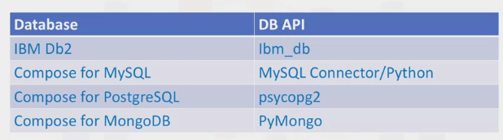

**Concepts of the Python DB API**

1. Connection Objects
   1. Database connections
   2. Manage transactions
2. Cursor Objects
   1. Database queries
   2. Scroll through the result set (like a text processing system)
   3. Retrieve results

**What are Connection Methods?**

1. Cursor(): Returns a new cursor object using the connection
   1. Callproc()
   2. Execute()
   3. Executemany()
   4. Fetchone()
   5. Fetchmany()
   6. Fetchall()
   7. Nextset()
   8. Arraysize()
   9. Close()
2. Commit(): Used to commit any pending transaction to the database
3. Rollback(): Causes the database to roll back to the start of any pending transaction
4. Close(): Used to close a database connection

**Writing code using DB-API**

1. Import dbmodule using API from that module
   1. #create connection object
   2. Connection=connect(‘databasename’, ‘username’, ‘pswd’)
   3. #create a cursor object
   4. Cursor=connection.cursor()
   5. #Run Queries
   6. Cursor.execute(‘select*from mytable’) Results = cursor.fetchall()
   7. #free resources
   8. Cursor.close()

**Connecting to a Database using IBM_DB API**

1. IBM_db API uses the IBM Data Server Driver for ODBC and CLI APIs to connect to IBM DB2 and Informix

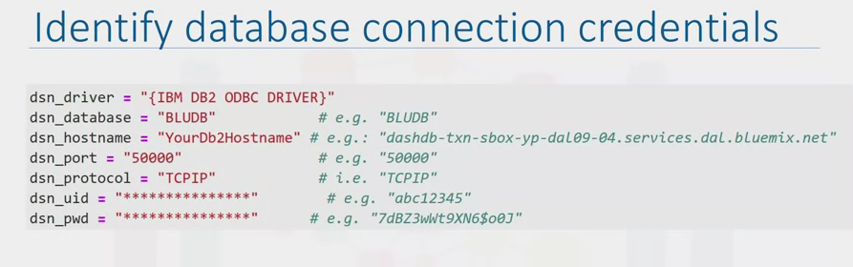

1. DSN: connection object (stores connection credentials)
2. Close the database connection
   1. Ibm_dbclose(conn)

**Import the ibm_db Python library**

The ibm_db [API](https://pypi.python.org/pypi/ibm_db/?utm_medium=Exinfluencer&utm_source=Exinfluencer&utm_content=000026UJ&utm_term=10006555&utm_id=NA-SkillsNetwork-Channel-SkillsNetworkCoursesIBMDeveloperSkillsNetworkDB0201ENSkillsNetwork20127838-2021-01-01)provides a variety of useful Python functions for accessing and manipulating data in an IBM® data server database, including functions for connecting to a database, preparing and issuing SQL statements, fetching rows from result sets, calling stored procedures, committing and rolling back transactions, handling errors, and retrieving metadata.

We first import the ibm_db library into our Python Application

Execute the following cells by clicking within it and then press Shift and Enter keys simultaneously

The following required modules are pre-installed in the Skills Network Labs environment. However if you run this notebook commands in a different Jupyter environment (e.g. Watson Studio or Ananconda) you may need to install these libraries by removing the # sign before !pip in the code cell below.

[ ]:

*# These libraries are pre-installed in SN Labs. If running in another environment please uncomment lines below to install them:*

*# !pip install --force-reinstall ibm_db==3.1.0 ibm_db_sa==0.3.3*

*# Ensure we don't load_ext with sqlalchemy>=1.4 (incompadible)*

*# !pip uninstall sqlalchemy==1.4 -y && pip install sqlalchemy==1.3.24*

*# !pip install ipython-sql*

[ ]:

**import** ibm_db

When the command above completes, the ibm_db library is loaded in your notebook.

**Identify the database connection credentials**

Connecting to dashDB or DB2 database requires the following information:

* Driver Name
* Database name
* Host DNS name or IP address
* Host port
* Connection protocol
* User ID (or username)
* User Password

**Notice:** To obtain credentials please refer to the instructions given in the first Lab of this course

Now enter your database credentials below and execute the cell with Shift + Enter

[ ]:

*#Replace the placeholder values with your actual Db2 hostname, username, and password:*

dsn_hostname **=** "YourDb2Hostname" *# e.g.: "54a2f15b-5c0f-46df-8954-7e38e612c2bd.c1ogj3sd0tgtu0lqde00.databases.appdomain.cloud"*

dsn_uid **=** "YourDb2Username" *# e.g. "abc12345"*

dsn_pwd **=** "YoueDb2Password" *# e.g. "7dBZ3wWt9XN6$o0J"*

​

dsn_driver **=** "{IBM DB2 ODBC DRIVER}"

dsn_database **=** "BLUDB" *# e.g. "BLUDB"*

dsn_port **=** "YourPort" *# e.g. "32733"*

dsn_protocol **=** "TCPIP" *# i.e. "TCPIP"*

dsn_security **=** "SSL" *#i.e. "SSL"*

**Create the DB2 database connection**

Ibm_db API uses the IBM Data Server Driver for ODBC and CLI APIs to connect to IBM DB2 and Informix.

Lets build the dsn connection string using the credentials you entered above

[ ]:

*#DO NOT MODIFY THIS CELL. Just RUN it with Shift + Enter*

*#Create the dsn connection string*

dsn **=** (

"DRIVER={0};"

"DATABASE={1};"

"HOSTNAME={2};"

"PORT={3};"

"PROTOCOL={4};"

"UID={5};"

"PWD={6};"

"SECURITY={7};").format(dsn_driver, dsn_database, dsn_hostname, dsn_port, dsn_protocol, dsn_uid, dsn_pwd,dsn_security)

​

*#print the connection string to check correct values are specified*

print(dsn)

Now establish the connection to the database

[ ]:

*#DO NOT MODIFY THIS CELL. Just RUN it with Shift + Enter*

*#Create database connection*

​

**try**:

conn **=** ibm_db.connect(dsn, "", "")

print ("Connected to database: ", dsn_database, "as user: ", dsn_uid, "on host: ", dsn_hostname)

​

**except**:

print ("Unable to connect: ", ibm_db.conn_errormsg() )

​

Congratulations if you were able to connect successfuly. Otherwise check the error and try again.

[ ]:

*#Retrieve Metadata for the Database Server*

server **=** ibm_db.server_info(conn)

​

print ("DBMS_NAME: ", server.DBMS_NAME)

print ("DBMS_VER: ", server.DBMS_VER)

print ("DB_NAME: ", server.DB_NAME)

[ ]:

*#Retrieve Metadata for the Database Client / Driver*

client **=** ibm_db.client_info(conn)

​

print ("DRIVER_NAME: ", client.DRIVER_NAME)

print ("DRIVER_VER: ", client.DRIVER_VER)

print ("DATA_SOURCE_NAME: ", client.DATA_SOURCE_NAME)

print ("DRIVER_ODBC_VER: ", client.DRIVER_ODBC_VER)

print ("ODBC_VER: ", client.ODBC_VER)

print ("ODBC_SQL_CONFORMANCE: ", client.ODBC_SQL_CONFORMANCE)

print ("APPL_CODEPAGE: ", client.APPL_CODEPAGE)

print ("CONN_CODEPAGE: ", client.CONN_CODEPAGE)

**Close the Connection**

We free all resources by closing the connection. Remember that it is always important to close connections so that we can avoid unused connections taking up resources.

[ ]:

ibm_db.close(conn)

**Creating Tables, Loading Data and Querying Data**

1. Connect to the database

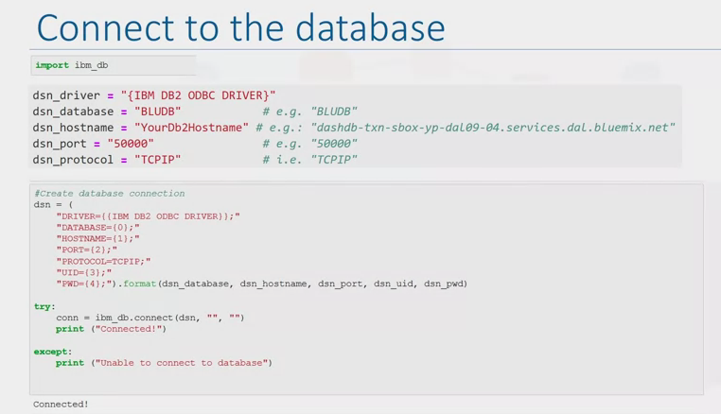

1. Either create the table on db2 (sql) or Python and R environments
2. How to create tables in db2 from Python
   1. Ibm_db.exec_immediate()
3. Parameters for the function:
   1. Connection (valid database connection resource)
   2. Statement (string that contains the SQL statement)
   3. Options (optional parameter that includes a dictionary that specifies the type of cursor to return for result sets
4. Code to create a table in Python:

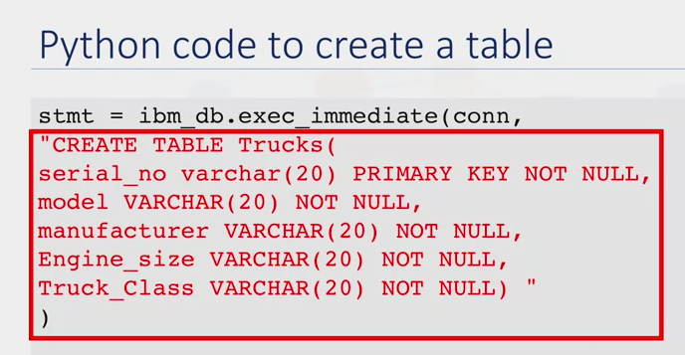

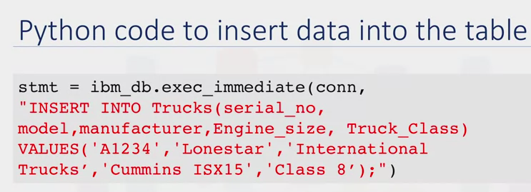

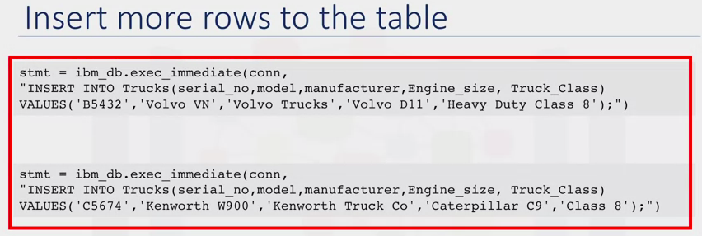

1. How to collect data from db2 using Python code

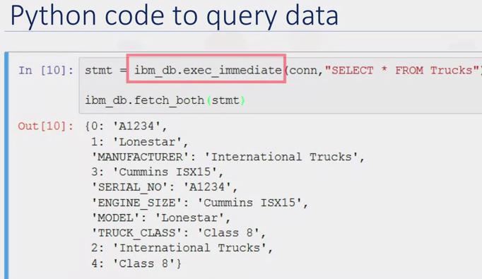

1. Using pandas to collect data from database tables
   1. Load data from table into a dataframe called “df”
   2. DF = represents tabular spreadsheet-like data structure

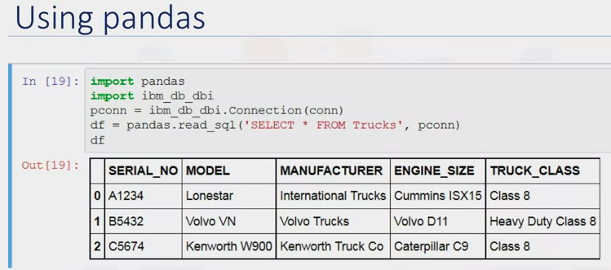

**Analyzing data with Python**

1. Load CSV fil into DB2 on Cloud
2. Four Steps:
   1. Source: Load spreadsheet into DB2 using the console
   2. Target: Select target Scheme
   3. Define: If creating a new table, you have the option to name table. You will then see a preview of the data where you can define columns and data types
   4. Finalize: Review and complete
3. You can then use Python to run scripts to retrieve data from and write data to a db2 database
   1. Generate statistical models and to plot these models

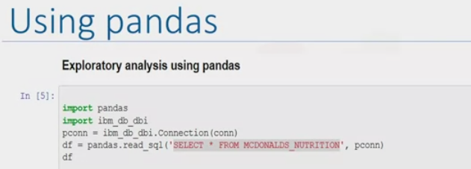

1. Load data from the macdonalds nutritional database into the dataframe DF using the read_sql method

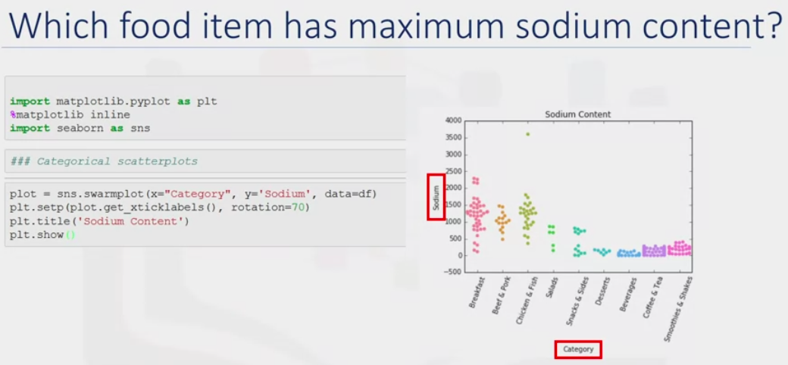

1. Which food item has maximum sodium content?

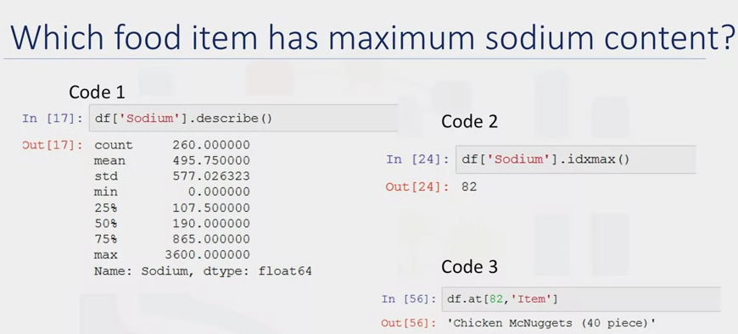

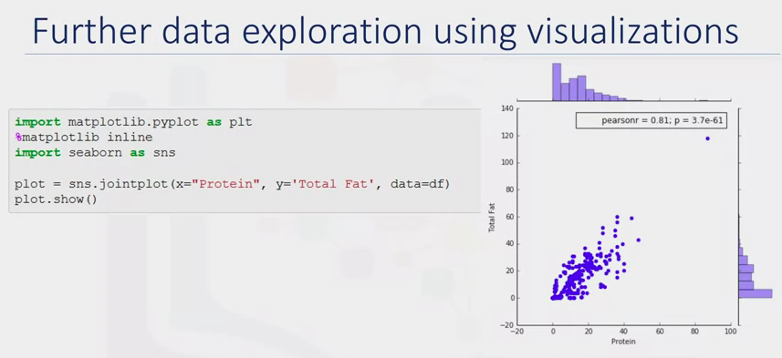

1. Visualize data using boxplots
   1. Charts that indicate the distribution of one or more variables
   2. Box in the box plot captures the middle 50%, line and points indicate possible skewness and outliers

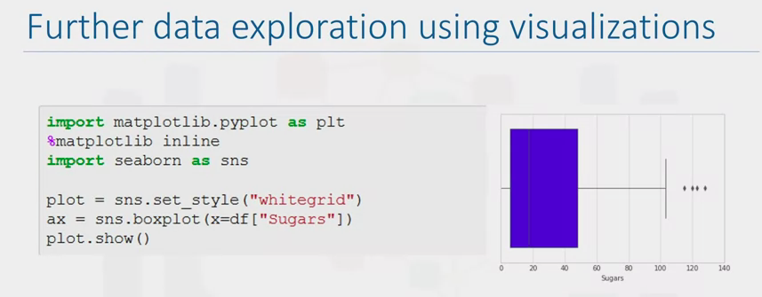

**Working with Real World Data Sets and Built-in SQL Functions**

1. Many real data sets are .CSV files
   1. Comma Separated Values

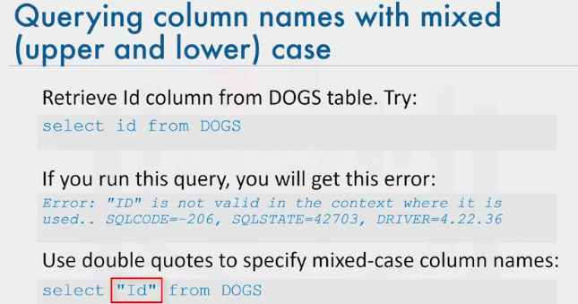

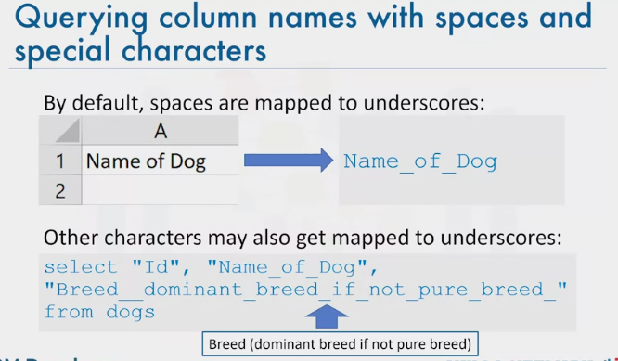

1. Notice the use of the double underscore replacing brackets (breed__dominant / Breed__”

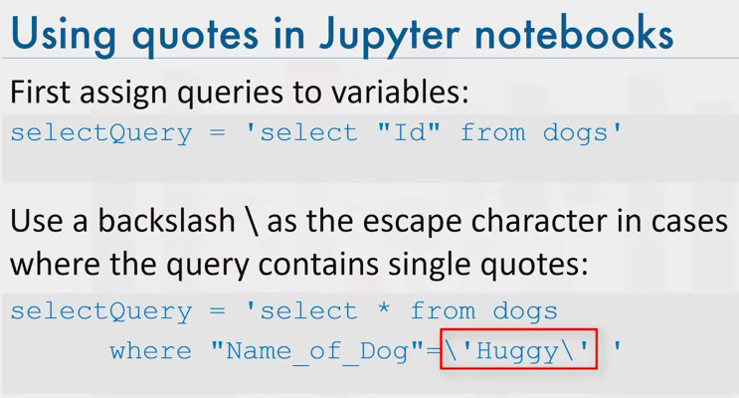

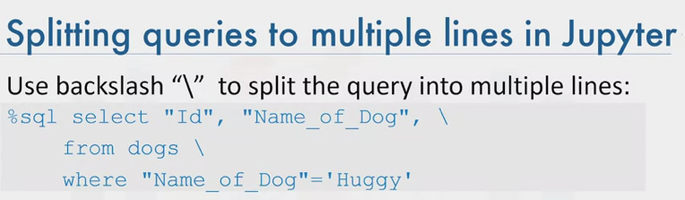

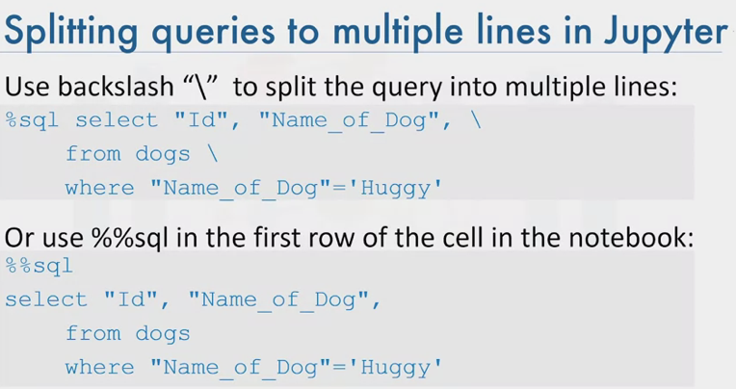

1. \ not needed when using sql magi (%%sql)

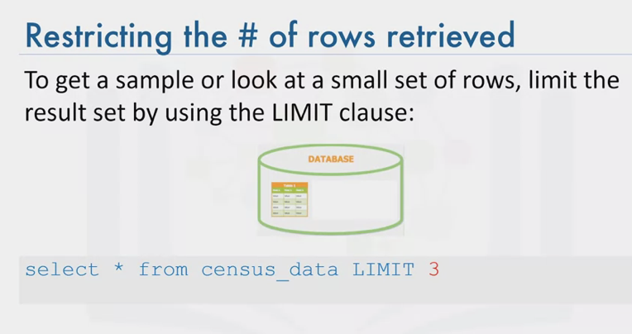

**Getting Table and Column Details**

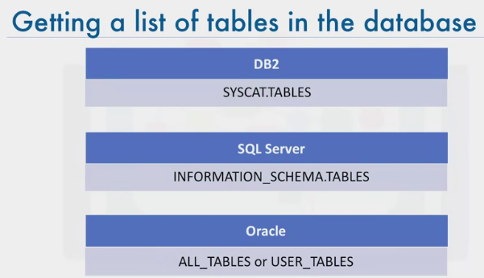

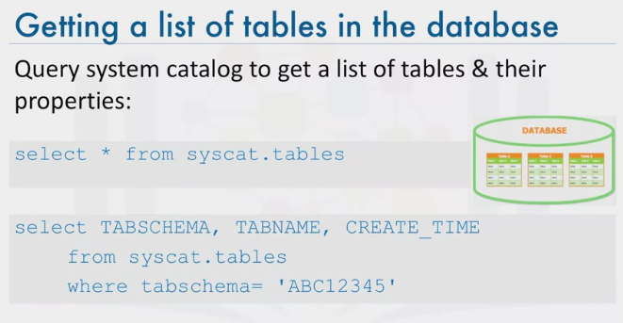

1. Replace ‘ABC12345’ with username

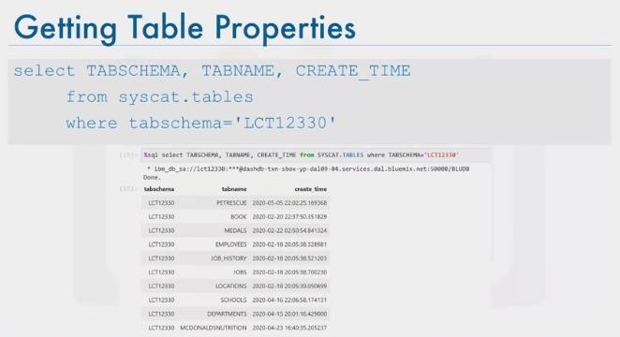

1. List of tables by time they were edited

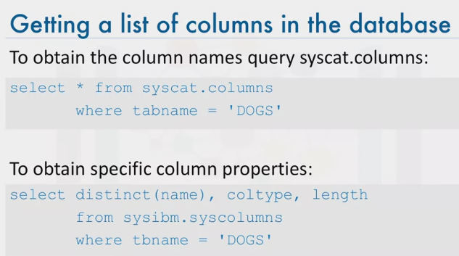

**Retrieve Table Metadata**

%sql select TABSCHEMA, TABNAME, CREATE_TIME from SYSCAT.TABLES where TABSCHEMA='YOUR-DB2-USERNAME'

or, you can retrieve list of all tables where the schema name is not one of the system created ones:

%sql select TABSCHEMA, TABNAME, CREATE_TIME from SYSCAT.TABLES \

where TABSCHEMA not in ('SYSIBM', 'SYSCAT', 'SYSSTAT', 'SYSIBMADM', 'SYSTOOLS', 'SYSPUBLIC')

or, just query for a specifc table that you want to verify exists in the database

%sql select * from SYSCAT.TABLES where TABNAME = 'SCHOOLS'

**Retrieve Column data**

%sql select count(*) from SYSCAT.COLUMNS where TABNAME = 'SCHOOLS'

**Retrieve the list of columns in SCHOOLS table and their column type (datatype) and length.**

<!-- Solution:

%sql select COLNAME, TYPENAME, LENGTH from SYSCAT.COLUMNS where TABNAME = 'SCHOOLS'

or

%sql select distinct(NAME), COLTYPE, LENGTH from SYSIBM.SYSCOLUMNS where TBNAME = 'SCHOOLS'

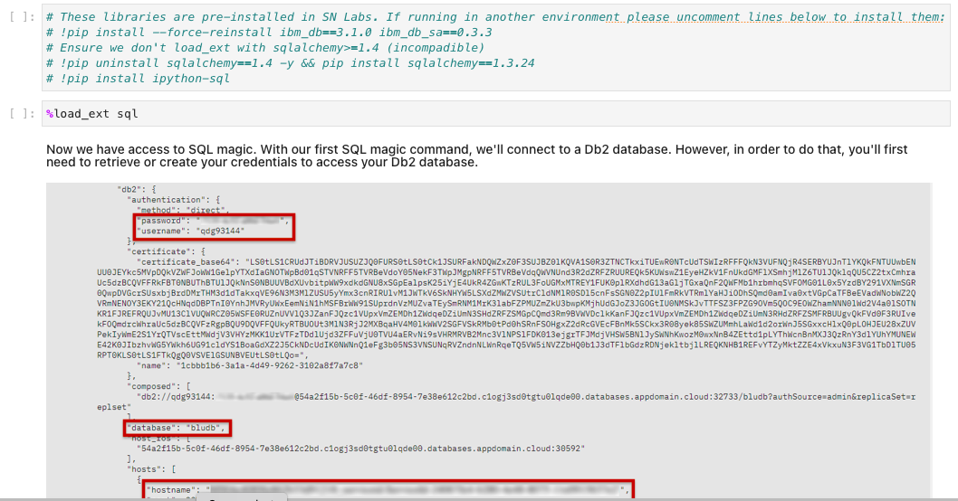

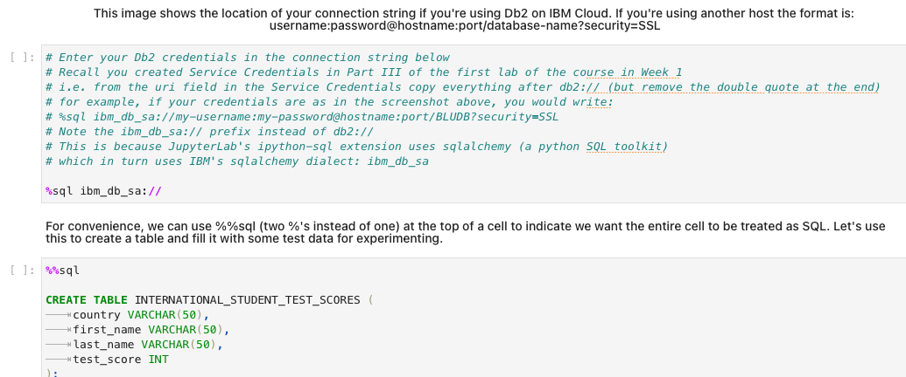

**WEEK 6 HONOURS MODULE – VIEWS, STORED PROCEDURES and TRANSACTIONS**

1. Alternative way of representing data that exists in 1 or more table or view
2. Can include specified columns from multiple base tables and existing views
3. Once created, can be queried like a table
4. Only the definition of the view is stored, not the data (the data that the view represents is stored in the base tables)

**Why should you use a view?**

1. Show a selection of data for a given table
   1. Omit sensitive data (tax, age, salary, etc)
2. Combine two or more tables in meaningful ways
3. Simplify access to data
   1. By granting access to a view without granting access to the underlying tables
4. Show only portions of data to the process that uses the view

